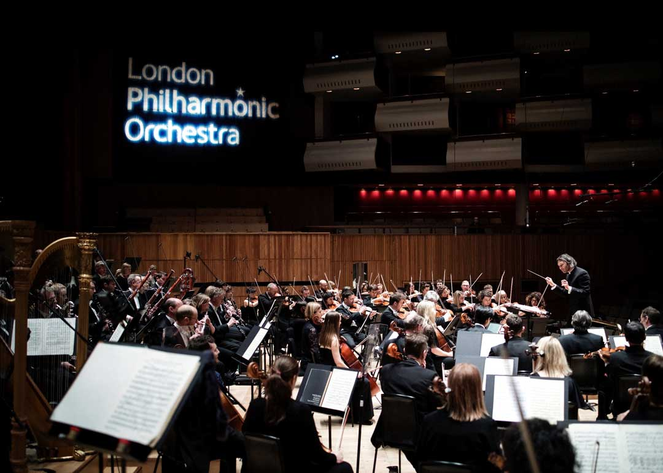­­­­

­­­

**PA to the Executive & Office Manager**

Recruitment Pack

**Contents**

About us 2

What to expect when working with us 3

About the role 4

Main tasks 5

Person specification 6

How to apply 7

**lpo.org.uk**

­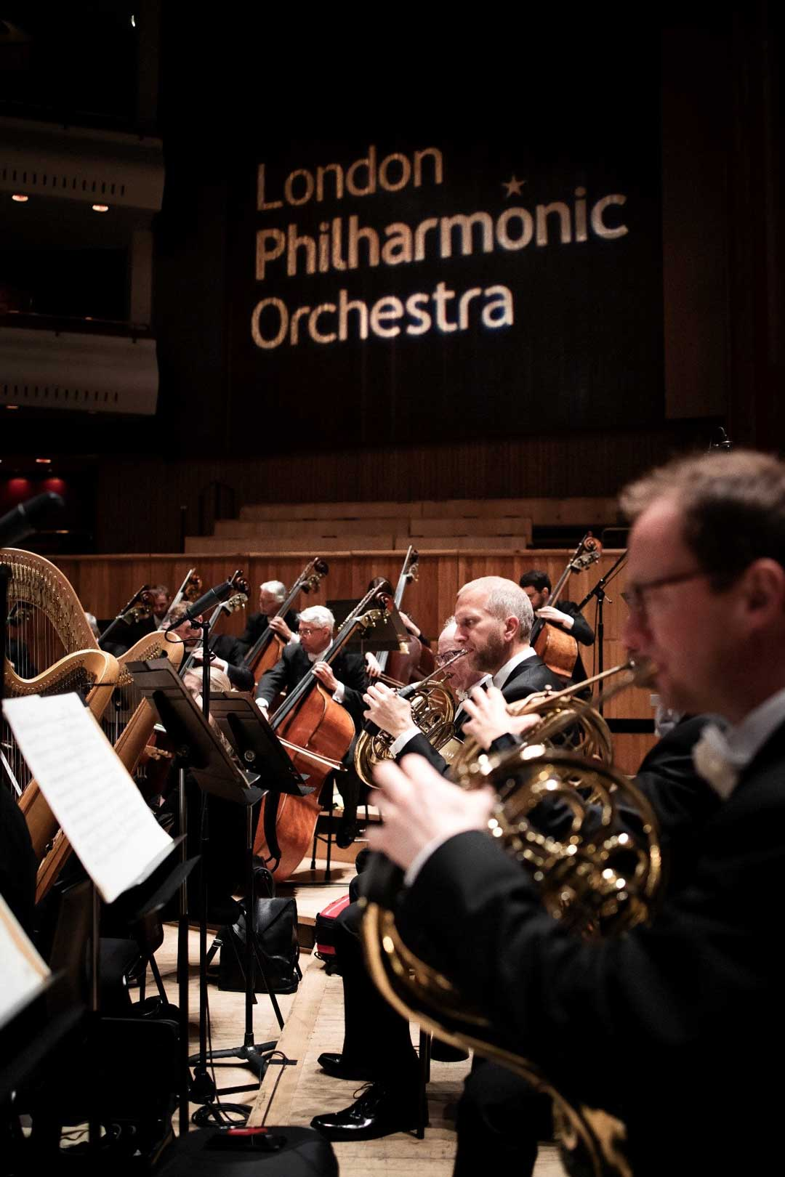 **About us**

Uniquely ground-breaking and exhilarating to watch and hear, the London Philharmonic Orchestra has been celebrated as one of the world’s great orchestras since 1932. Our company mission is **‘to share wonder with the modern world through the power of orchestral music’**, which we achieve through our exceptional programmes, pioneering education and community projects, acclaimed recordings and trailblazing international tours. The Orchestra balances a long and distinguished history with its reputation as one of the UK’s most forward-looking ensembles, and is internationally recognised as a leading world orchestra providing excellence, versatility, invention and inclusivity in all that we do.

We are committed to sharing the wonder of world-class music with the broadest possible audience. Over the last three decades, our Education and Community department has introduced many people to orchestral music and created opportunities for people of all backgrounds to fulfil their creative potential, reaching over 23,000 people last year (2023/24) alone. Our programmes provide first musical experiences for children and families; the leading talent development schemes for emerging instrumentalists, composers and conductors; and significant programmes with both adults and young people living with disability. We place a strong value on Equity, Diversity and Belonging in all that we do, with significant development and programming initiatives in this area. All of our programmes allow participants to bring their creativity, enthusiasm and unique perspectives into the LPO to revitalise, enrich and enhance our practice and our relevance to the world in which we live.

The LPO prides itself at being on the forefront of technology, continually finding new and innovative ways to share   
our music with millions of people worldwide. We have 1.5m followers across all social media channels alongside   
c.150 million streams across Spotify and Apple, and continue our reign as the most-followed professional orchestra on TikTok throughout 2024. We can be heard on award-winning film soundtracks such as *The Lord of the Rings*, on computer games, and recorded ‘Backstage with the London Philharmonic Orchestra’, a four-part docuseries with Sky Arts, which aired in 2024. We also reach audiences through our partnership with Marquee TV, which allows us to broadcast live concerts and enables better accessibility for viewers to share and relive the wonder of our music from anywhere and everywhere.

At the heart of the LPO we champion a strong commitment to corporate citizenship, reflecting on, engaging with, and acting upon the challenges of today’s society. To our employees we promise an inclusive, respectful environment where you will find a warm welcome and a strong sense of belonging, whatever your background. It is our aim that staff can see themselves in the Orchestra’s work, and that their voices are heard through regular company initiatives that offer opportunities to feedback and contribute. Such values are also recognised through our music, with recent season programmes exploring key moments in history and topics such as migration and the power of creativity.   
We are committed to ensuring that our operations are as sustainable as possible and that the Orchestra delivers significant impact across all areas of its activity.

**What to expect when working with us**

Prior to starting at the LPO you will be equipped with all the relevant information to ensure a seamless start with the company. During your induction you will meet one-to-one with each member of the senior management team, be assigned a ‘buddy’, be introduced to all members of staff, and have tours of our office, rehearsal venue and the Southbank Centre, where we are resident orchestra. We have a small office team of 33, alongside our ‘On the Road’ team of six. We are a unified and friendly organisation who encourage you to learn first-hand from the experience of others, build valuable relationships and showcase your innovative thinking and abilities, all while being supported within a collaborative, inclusive and enjoyable working environment.

We offer a range of company benefits aimed at promoting wellbeing, goodwill and an engaged workforce:

* 25 days of annual leave per annum, rising by one day for each full year of service (September–August) to a maximum of 28 days
* After three months in the position, access to a 6% contributory pension scheme
* Two complimentary tickets for all of the LPO’s Royal Festival Hall own-promoted concerts
* A total of four seats each summer for Final Dress Rehearsals at Glyndebourne Festival Opera
* Discounts at food/drink and retail outlets across the Southbank Centre site
* Discounted access to various galleries and museums across London through the Southbank Centre’s reciprocal scheme
* Season ticket scheme providing loans for annual travel passes
* Support in promoting and maintaining positive mental health, including access to Mental Health First Aiders, confidential support helpline and peer support
* Cycle to Work scheme
* Free eye tests and contribution towards spectacles where required

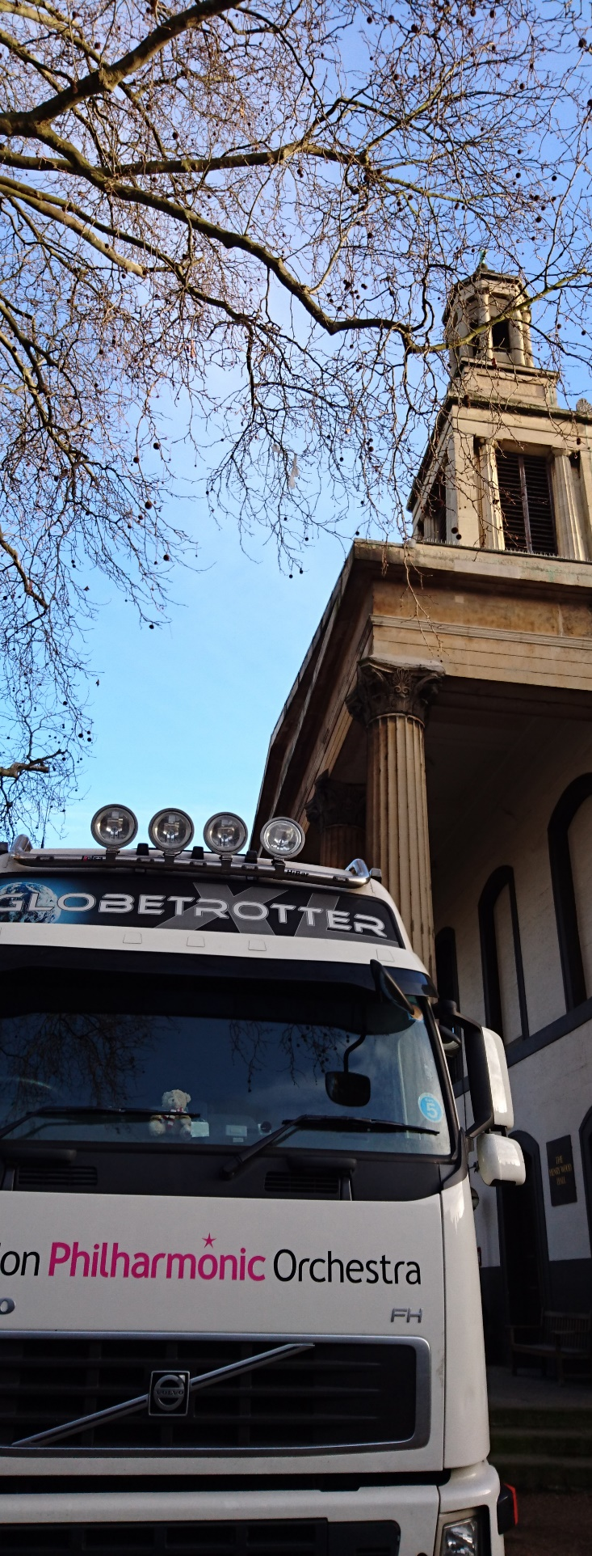**About the role**

**Job title** PA to the Executive and Office Manager

**Reports to** Chief Executive and Artistic Director

**Salary** £30,000

**Location** London Philharmonic Orchestra, 89 Albert Embankment, London, SE1 7TP. Three days working in the office and two days working from home per week.

**Hours** 9.30am–5.30pm Monday–Friday, with the option of hybrid working and staggered start/finish

times.

**Overall responsibilities**

The PA to the Executive and Office Manager role represents an exciting opportunity for an individual who enjoys problem solving and who has a passion and genuine desire to support and help others. The post holder will have exceptional organisational, time management and administration skills as they work closely alongside both the Chief Executive and Artistic Director, playing a vital role in ensuring the smooth running of a major leading arts organisation. The ideal candidate will be a confident communicator who can multitask and rely on their own intuition when anticipating needs, decision making and prioritising tasks. No two days are the same, so a high-level attention to detail and an adaptable approach to working is key.

This is a varied and engaging role, which allows you to work independently whilst also playing a critical part in building relationships and supporting the wider office team. As part of the Office Manager duties, there will be opportunities to work alongside the Chief Executive on developing and sustaining a positive, friendly and inclusive workplace culture.

This is an exciting time to join the LPO, joining at the beginning of a highly anticipated season and with room for role development and growth further down the line. If you enjoy providing efficient and effective administrative support, care deeply about fostering a positive work environment and have a solution-orientated attitude, then we would like to hear from you!

 **Main tasks**

**PA responsibilities**

* Acts as first point of contact for any internal and external stakeholders wanting to contact the Chief Executive (CE) or Artistic Director (AD)
* Manages CE and AD calendars by organising and scheduling in person and online meetings, including in and outside of London and across different time zones
* Works closely alongside both the CE and AD to ensure they are well informed of any upcoming commitments, following up with them when needed
* Monitors CE and AD inboxes, responding, flagging and filing emails as appropriate and necessary
* Schedules Board, Advisory Council and company committee and planning meetings, preparing papers and presentations when necessary
* Works alongside CE to organise annual all-staff company away day by arranging facilitators, venue, catering and entertainment
* Responds to event invitations addressed to the CE and AD, including follow ups required for directions, dress and security requirements
* Processes expense claims and receipts for CE and AD each month, including appropriate cost coding
* Assists in recruitment processes by writing job ads, advertising vacancies, anonymising applications and scheduling interviews, following up with candidates as necessary
* Administers the Fellow Conductors applications, and Conductors’ feedback
* Manages internal Glyndebourne ticket allocations each summer and invites company supporters to performances

**Office Manager responsibilities**

* Keeps the office tidy and organised, arranging any waste/recycling collections when needed
* Ensures the office is well stocked with stationery and relevant office supplies
* Logs guests onto the building portal for all external visitors
* Liaises with cleaning and building management as necessary
* Organises all-staff monthly lunches and team meetings
* Organises employee social events
* Organises quarterly company Q&As, handling confidential and sensitive staff questions addressed to CE and AD
* Leads inductions with new staff, issuing the company handbook and talking through working parameters, company policies and support available, ensuring they are well settled into the workplace
* Updates staff handbook and employee policies as and when necessary
* Maintains productive relationships and communication channels across the organisation with the ability to create rapport with a broad range of individuals
* Works closely alongside CE to sustain a positive and inclusive office culture

 **Person specification**

**Essential**

* Proven or recent experience as a Personal Assistant, preferably supporting senior executives or senior management
* Exceptional organisational skills and attention to detail, with the ability to prioritise tasks and manage multiple workloads effectively
* Effective communication skills, both written and verbal
* Ability to interact confidently with individuals at all levels
* Adaptability to work independently and as part of the wider office team
* A positive attitude and willingness to take on new challenges
* Discretion and confidentiality when managing sensitive information

**Desirable**

* An appreciation and interest in the arts and the classical music industry
* Experience of working in an arts and/or charity environment
* First Aid and Mental Health First Aid qualifications (training can be provided)

 **How to apply**

**The closing date for applications is Wednesday 6 August 2025.**

The interviews will take place on 18th and 19th of August 2025.

**The London Philharmonic Orchestra is committed to equal opportunities and diversity. We actively welcome applications from all sections of the community, recognising that we are stronger as a diverse team bringing a range of lived experiences to our goals of sharing the wonder of orchestral music.**

Please visit [lpo.org.uk/jobs](http://www.lpo.org.uk/jobs), where you will be asked to complete a short form before uploading your CV and covering letter. If you are unable to apply online, please contact David Burke, Chief Executive, at david.burke@lpo.org.uk for further information.

CVs should include:

* Details of relevant achievements and experience as well as educational and professional qualifications
* Details of your notice period and names of two referees, together with a brief statement of the capacity in which they have known you, along with an indication of when in the application process they may be contacted (please note that we will not contact your referees without your express permission)
* An indication of your current salary (if applicable)
* Contact details including day and evening telephone/mobile numbers

Your covering letter should summarise your interest in this post, providing evidence of your ability to match the criteria outlined in the Person Specification on page 6.