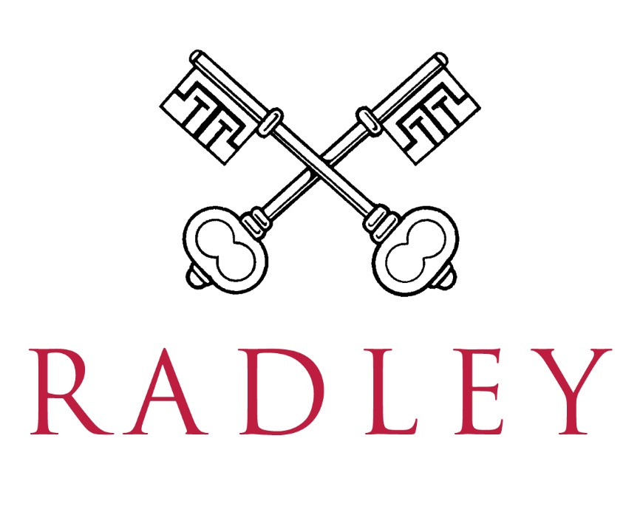
Trombone Teacher
January 2027

Radley College is seeking a teacher for a minimum of 7 trombone pupils, with opportunities to contribute to the school's ensemble programme by leading a chamber ensemble or brass group, or by assisting with sectional rehearsals. The ability to teach other lower brass instruments, such as euphonium and tuba, would be advantageous.

As well as knowledge of teaching strategies, teaching repertoire and adaptability to the individual, the successful applicant will show an active interest and insight into current instrumental teaching, research and development, and in pursuing their own professional development as an instrumental teacher. Most importantly, they will be committed to ensuring every pupil makes progress and develops a love of music, whether they are a beginner or a musician with many years’ experience

Further information and details on how to apply can be found on the school’s website: www.radley.org.uk/about-radley/employment/teaching-vacancies

The deadline for applications is 12 noon Thursday 24 September, but we reserve the right to consider applications as they arrive.

Radley College is committed to safeguarding and promoting the welfare of children and applicants must be willing to undergo child protection screening appropriate to the post, including checks with past employers and the Disclosure and Barring Service.

