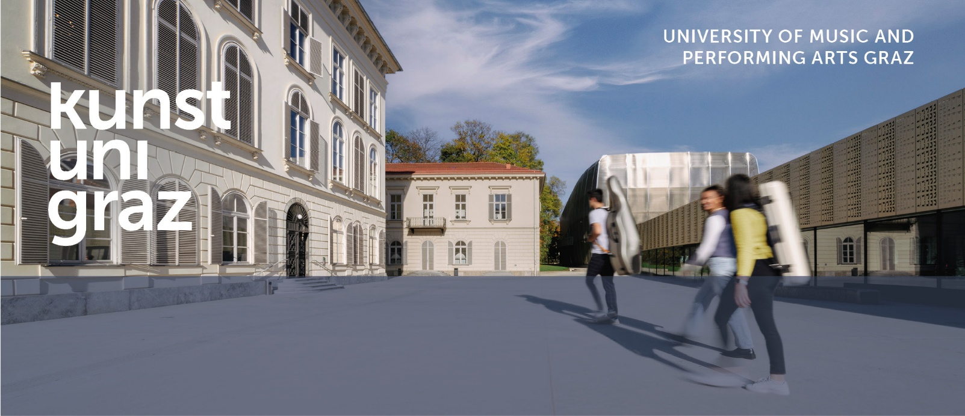
Visiting professor (f/m/d) of Violone
(usage example Senior Lecturer)

INstitute 15 – Early Music and Performance Practice
Start Date: winter semester 2026/27
Employment level: part-time, extent of 25 % of full-employment
Application deadline: 30.04.2026

Your Responsibilities
- independently conducting courses and administering exams,
- in particular:
- in the core artistic subject of the “Early Music” curriculum: historical string instruments/violone
- in the elective and specialization area of historical playing techniques
- in repertoire studies and organology of main subject
- supervision of students
- assistance with exams and evaluation measures
- assistance with the institute’s self-administration and with events

Your Profile
- a master’s degree (or equivalent) in a relevant artistic field, or proof of artistic aptitude comparable to such a degree
- outstanding personality with the highest qualifications for the position to be filled
- profound practical and theoretical expertise in the field of historical string bass instruments, particularly the violone in its various historical forms from the 16th to the 19th centuries, as well as experience with the various instruments ranging from 8 feet to 16 feet, including the “Viennese bass”
- experience and knowledge regarding the application of music theory and history on musical practice
- sensitivity in addressing gender, diversity, and sustainability

Please note that, in the event of a mutually agreed temporary extension, proof of German language proficiency at the B2 level must be provided no later than three years after the extension takes effect.

our Benefits
- a varied range of tasks
- a dynamic working environment with a pleasant working atmosphere
- attractive premises and excellent infrastructure
- outstanding media and instrument equipment
- internationality
- numerous internal and external training and development opportunities
- wide range of diverse university cultural events
- good work-life balance and cooperation with childcare facilities
- good public transport connections
- climate-friendly mobility promotion (subsidies, university bicycles)
- workplace health promotion
- the location offers a high quality of life and housing as well as a vibrant cultural life

Contract
- The employment contract is limited to one academic year, with the option of a (fixed-term) extension by mutual agreement.
- Employment level: Part-time employment at 25% (expected to consist of 2 teaching units weighted at 100% and 2 teaching units weighted at 75%).
- The employment level may be increased by mutual agreement through additional teaching assignments as needed.
- Salary: minimum monthly gross salary currently € 944,03 (14x annually) according to the collective bargaining Agreement for University Staff and may be increased based on the terms of the collective agreement, considering the professional experience relevant to the position.

The University of Music and Performing Arts Graz aims to increase the proportion of women among its artistic and scientific staff and therefore explicitly invites qualified women to apply. In the event of underrepresentation, women with equal qualifications will be given priority.

We want everyone in society, and especially in the workplace, to have equal opportunities. It is therefore particularly important to us not only to offer people with disabilities career opportunities, but also to provide them with the best possible support from the moment they apply. Diversity enriches our team!

We look forward to receiving your written application including a cover letter and other documents (CV, diplomas, list of publications, etc.) mentioning the reference number 20/26.
Applications to the email: bewerbung@kug.ac.at

Applicants are not entitled to compensation for the travel and lodging expenses that arise during the application procedure.

On the behalf of the rectorate
Georg Schulz

Für das Rektorat
Georg Schulz

APPLICATION TO
University of Music and Performing Arts Graz
Leonhardstraße 15, 8010 Graz (AT)
bewerbung@kug.ac.at
www.kug.ac.at
Info at phone no. +43 316 389–1147

The University of Music and Performing Arts Graz – the KUG – with around 2,300 students at its campuses in Graz and Oberschützen, is an international university offering a wide range of courses in music and the performing arts. Located in the heart of Europe, we build on the cultural heritage of our region and at the same time explore and contribute to current trends in the contemporary arts. We

engage with international developments in the arts, pedagogy and research, and explore the significance of art and culture in society. Teachers and students work cooperatively in this process. We are committed to fostering gender mainstreaming, diversity, and sustainability in order to transform the artistic and cultural sector, as well as to further develop our institution.

