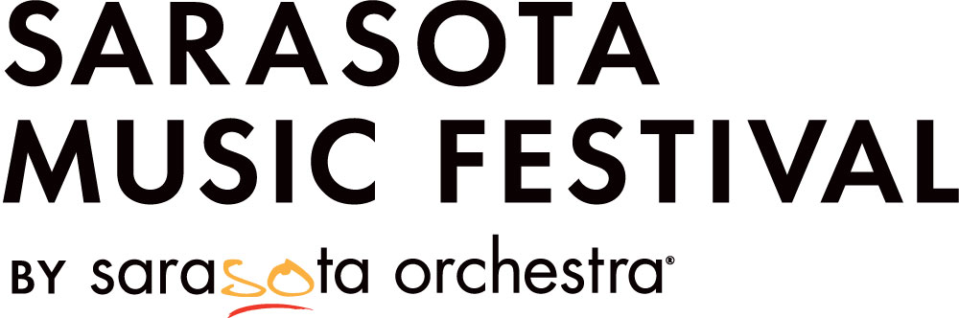

**Sarasota Music Festival Operations Internship**

January 13 – April 25, 2025 (remote) & May 27 – June 22, 2025 (in-person)

Sarasota Orchestra is currently seeking one intern to support the Sarasota Music Festival. The intern will have the opportunity to actively learn about many aspects of festival planning and operational functions necessary for coordinating a classical chamber music festival. This is an outstanding opportunity that will provide the selected intern with valuable experience and knowledge in arts administration.

**Internship Summary:** The Festival intern will work closely with the Director of Artistic Operations to support the implementation and planning of day-to-day activities of the Festival. The Festival intern’s primary function is to ensure that a variety of events (rehearsals, concerts, masterclasses, community outreach) run smoothly. The Festival intern is expected to orient to and learn about the festival processes overall.

Key responsibilities:

* Work with the Director of Artistic Operations to coordinate the fellow application and audition process
* Draft correspondence from Sarasota Music Festival to applicants, accepted fellows, and faculty
* Collate and organize fellow data collected via the Festival Portal, including repertoire, housing, and dietary preferences
* With Director of Artistic Operations, create a dynamic, updatable digital Festival schedule accessible by faculty, fellows, and staff
* Organize travel logistics for fellows and faculty
* Support the efforts of the Artistic Coordinator to ensure artist hospitality needs are met
* Facilitate Festival registration and orientation
* Interface with artistic personnel, administrative staff, Festival Fellows, donors, and patrons
* Liaise with the Marketing department to coordinate radio and television interviews and assist with social media efforts
* Collaborate with the Development team to staff the Festival Pass desk, interacting with donors and patrons, and special guests
* Provide on-the-ground assistance with Fellow community outreach performances

Additional duties will be discussed individually to tailor the experience to the intern’s interests and skills.

Required Skills/Attributes:

* Must be organized, detail-oriented, and able to prioritize multiple projects at the same time
* Proficiency with Microsoft Office Suite, especially Excel
* Excellent written and verbal communication skills
* Ability to work in fast-paced environment with a variety of personalities
* Valid driver’s license with 3+ years driving experience and willingness to operate large passenger van

Preferred Qualifications:

* Graduate student in arts administration
* Bachelor’s degree in music or arts
* Background in classical music with strong knowledge of chamber repertoire
* Interest in pursuing arts administration as a career

Applicants must be able to commit to the entire internship beginning January 13 and concluding June 25, 2025. Specific work dates and time-off can be coordinated with the selected candidate, but this opportunity is for one internship.

**Schedule:**

Remote Internship - January 13 – April 25, 2025 (120 hours, average 8 hrs./week)

In-Person Internship - May 27 – June 22, 2025 (180 hours, average 45 hrs./week)

Hours for the remote portion of the internship are flexible, but ideally would occur with regularity. In-person hours vary based on the daily Festival schedule and needs. The Festival hours of operation are 7:30 AM – 10:00 PM Mon.-Sat. and 1:00 PM – 10:00 PM on Sunday.

**Compensation:** $3,900 ($1,560 remote internship, $2,340 in-person internship; $13/hr.)

**Housing, Meals, and Transportation:** Sarasota Music Festival will provide housing within walking distance to Beatrice Friedman Symphony Center for the in-person portion of the internship. A continental breakfast and lunch are provided Monday-Saturday. Several dinners are also provided. Transportation to and from Sarasota is the responsibility of the intern.

**College Credit:** Upon timely request, Sarasota Music Festival is happy to complete necessary paperwork for the intern to receive college internship credit through the intern’s college or university.

**Physical Requirements:** While performing the duties of this job, the employee is regularly required to talk, hear, sit, stand, walk, bend, reach, and use hands to finger, handle or feel. Repetitive motion is required while using a computer. The intern is required to have close visual acuity to perform an activity such as preparing and analyzing data and figures and viewing a computer terminal. This position requires the ability to occasionally lift and/or move up to 50 pounds.

**Working Conditions:** The job operates in a professional environment including office and performance hall settings. The environment is generally moderate in temperature and noise level.

**About Sarasota Music Festival:** The Sarasota Music Festival is an intense three-week experience of chamber music, masterclasses, and concerts with the coaching and performance of chamber music as its focus. Sarasota Music Festival began in 1965 as a one-week event with seven guest mentors. Over the years, the festival continued to expand and receive national and international attention. In 1984 it was designated by the Florida State Legislature as the "Official Teaching and Performing Festival of the State of Florida." Following 10 years of leadership by Robert Levin, Jeffrey Kahane was appointed the festival's Music Director in 2016.

There are more than 40 guest artists, including many of the festival's own alumni. These masters represent nearly all major American orchestras and a cross-section of renowned music schools, conservatories, and institutes of music. The fellows range from professional-level musicians to superior students in music schools and conservatories. Several travel from other countries to participate.

Festival audiences are entertained by a wide variety of symphonic artistry including: Thursday afternoon Artist Showcase concerts, Friday Festival chamber concerts, Saturday Symphony orchestra concerts, and Rising Stars Fellow chamber performances. Many patrons enjoy the option of purchasing Festival Passes, which allows them access to the artists' masterclasses and rehearsals.

**Questions and applications/interest for the Festival internship should be directed to the Director of Artistic Operations, Olivia Steinman Deems (**[**osteinman@sarasotaorchestra.org**](mailto:osteinman@sarasotaorchestra.org)**). To apply, please send in your resume and a cover letter. The final deadline for applications is October 31,2024.**

Sarasota Orchestra is an Equal Opportunity Employer.