**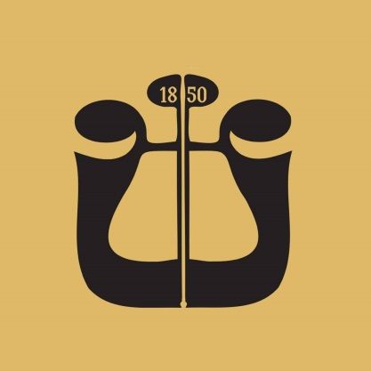  
  
  
  
Audition – Second Clarinet**

* Bartók – Concerto for Orchestra, Movement II – from measure 181 to measure 212
* Pancho Vladigerov – Rhapsody “Vardar” – from the fourth measure of rehearsal 26 to the fourth measure of rehearsal 27
* R. Korsakov – Scheherazade, Movement I – from the fifth measure of rehearsal F to rehearsal G
* H. Berlioz – Symphonie Fantastique, Movement V – from the fourth measure of rehearsal 83 to rehearsal 84