**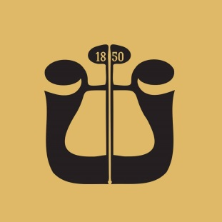  
  
  
  
Exam Program:**

* A slow and a fast movement from J. S. Bach’s Solo Cello Suites – of the candidate’s choice
* First movement with cadenza **or** second and third movements from a concerto by J. Haydn in C or D major
* Orchestral excerpts:
  + L. van Beethoven – Symphony No. 5
  + J. Brahms – Symphony No. 2
  + B. Smetana – The Bartered Bride
  + S. Prokofiev – Romeo and Juliet, Suite No. 2