**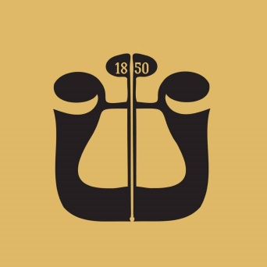  
  
  
Audition – E-flat Clarinet**

* Shostakovich – Symphony No. 5, Movement II – from rehearsal 49 to four measures before rehearsal 51
* Stravinsky – The Rite of Spring, Part I – from the third measure after rehearsal 9 to rehearsal 12
* Ravel – Boléro – from rehearsal 3 to rehearsal 4
* R. Strauss – Till Eulenspiegel – first 8 measures of rehearsal 40
* H. Berlioz – Symphonie Fantastique, Movement V – from rehearsal 63 to four measures before rehearsal 65
* Ravel – Daphnis et Chloé, Suite No. 2 – from rehearsal 200 to rehearsal 202
* Shostakovich – Symphony No. 6, Movement II – from rehearsal 34 to rehearsal 37
* Ravel – Piano Concerto, Movement III – from rehearsal 1 to two measures before rehearsal 2