**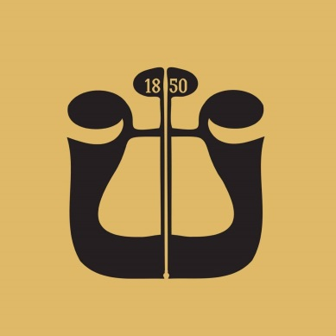  
  
Exam Program:**

**Snare Drum**

* M. Peters – Etude No. 9 from Advanced Snare Drum Studies
* N. Rimsky-Korsakov – Scheherazade, Movements III and IV
* S. Prokofiev – Peter and the Wolf
* M. Ravel – Boléro (approx. 1 minute)
* Tremolo exercise

**Xylophone**

* Deleporte – Rococo, Etude No. 8 from 20 Petites Pièces en forme d’études
* G. Gershwin – Porgy and Bess
* I. Stravinsky – Petrushka (1911 version)

**Vibraphone**

* L. Bernstein – Symphonic Dances from West Side Story

**Crash Cymbals**

* P. I. Tchaikovsky – Symphony No. 4, Movement IV
* P. I. Tchaikovsky – Romeo and Juliet Overture-Fantasy
* S. Rachmaninoff – Piano Concerto No. 2, Movement III

**Tambourine**

* G. Bizet – Excerpts from Carmen
* P. I. Tchaikovsky – Russian Dance – Trepak from The Nutcracker
* A. Dvořák – Carnival Overture

**Timpani**

* W. A. Mozart – Overture to The Magic Flute
* L. van Beethoven – Symphony No. 7, Movement I

**Bass Drum**

* G. Mahler – Symphony No. 3
* I. Stravinsky – The Rite of Spring